We have been learning about ….
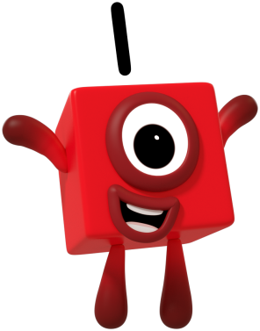
Number 1

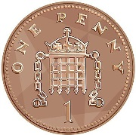
1p
A circle has 1 side.

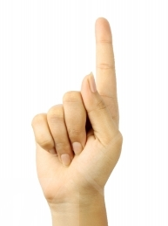
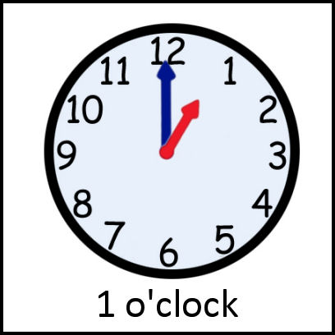
One means being alone!

Can you find some things you just have one of? Draw them here…

Can you recognise and write number 1.
Start at the top and down we run. That’s the way we make a 1.
1 _________________________________________________________________________
_____________________________________________________________________________

We have been learning about ….
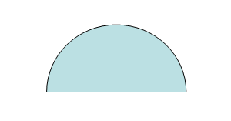
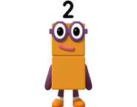
Number 2
A semi-circle has 2 sides.
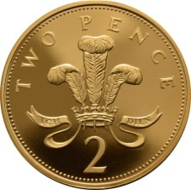
2p
2p
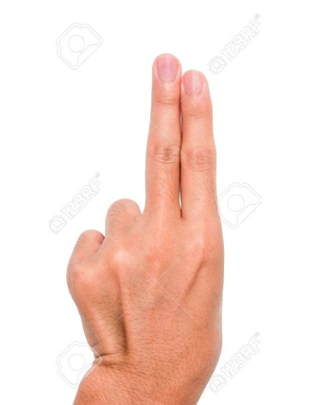

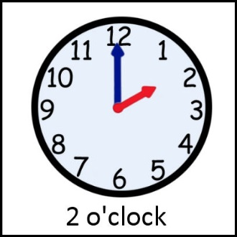
1 + 1 = 2
Can you recognise and write number 2.
Round and back on the railroad track. Two, Two, Two.
2 ________________________________________________________________________
____________________________________________________________________________
Can you find some things you have two of? Draw them here…

