We have been learning about ….
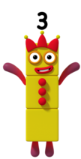
Number 3

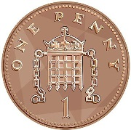
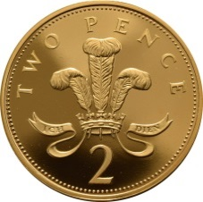
A triangle has 3 sides and 3 corners.

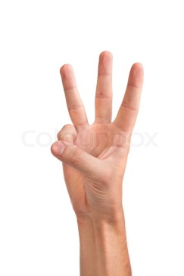
2p + 1p = 3p
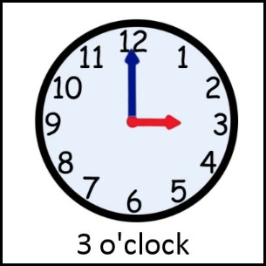
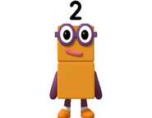

= 3
+

Can you find some things that have 3 (knife, fork, spoon, shape, toy)? Draw them here…

Can you recognise and write number 3.
Round the tree and round the tree. That’s the way we make a three.
3 _________________________________________________________________________
_____________________________________________________________________________

We have been learning about ….

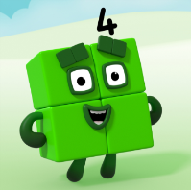
Number 4
Squares, rectangles and rhombuses have 4 sides and 4 corners.

2p + 2p = 4p

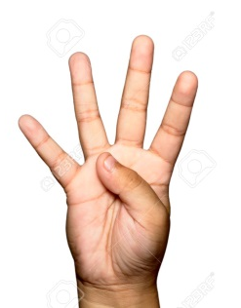
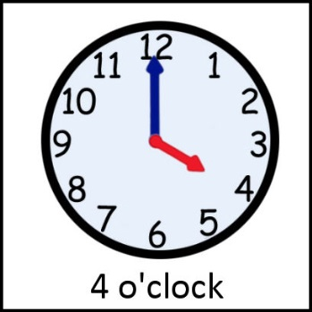
1 + 1 + 1 + 1 = 4
Can you find some things that have 4 of something (chair, picture frame)? Draw them here…
Can you recognise and write number 4.
Down and across and down some more. That’s the way we make a 4.
4 ________________________________________________________________________
____________________________________________________________________________

